**October 2024**

**Home Reading:**

Dear Parents and Carers,

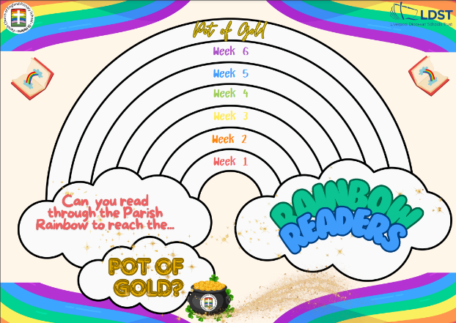This half term, behind the scenes, staff have been working incredibly hard to set up our new home reading system. Your child will come home with a book banded ‘Challenge book’ and/or a reading book from our class library. Over the next half term leading up to Christmas, we aim to have all children assessed and provided with a ‘Challenge book’ to ensure we are helping all our learners to reach their full reading potential. You will be sent home some hints and tips with how you can help your child succeed in reading, based on our assessments which produce areas of development. We will track the coverage of texts to ensure that your child is reading a varied range of books. There is no correlation to the previous system, so please don’t worry if you think your child has moved down a level. This isn’t the case. Children who are accessing phonics (Read Write Inc) will continue to bring a RWInc book home.

We are also launching a new reading reward scheme. We are asking for the children to read 4 times a week at home. If they are successful in this, each week they can climb up the ‘Parish Reading Rainbow’. At the end of each half term, children who have read consistently throughout the 6 weeks will be able to enjoy a treat. This might be a hot chocolate and Christmas film in Autumn 2 or an ice pop and extra playtime in Summer term. In addition to this, we will continue to have the Bronze, Silver and Gold certificates to recognise the children who have consistently read all year. This can be found in the Reading Records.

We hope that you will help us to support your child on their reading journey. We always endeavour to work in partnership with you to ensure reading is at the beating heart of all we do and that your child becomes a life-long reader.

Many thanks,

Mrs Flanders,

English Lead