Dear Parent/Guardian,

Today, we had the pleasure of hosting author Sean Perkins, who visited our school to read from his latest book, *Oscar and Ben – The Sleepover.* This exciting new release is the third instalment in the popular Oscar and Ben series. We’re thrilled to offer you the chance to purchase a signed copy of this book. Orders will be accepted until [INSERT DATE], and books will be delivered shortly after for your child to bring home.

In addition, Sean will have copies of his first two books available, and is offering a special discount if you’d like to purchase all three titles. The prices are as follows:

* £22.00 for all three books
* £15.00 for any two books
* £8.00 for a single book

If you would like your child’s book(s) signed by the author, please complete and return the slip below, indicating the title(s) you wish to order. Please place your order in a sealed envelope, clearly marked with your child’s name(s) and their teacher’s name.

Yours Sincerely,

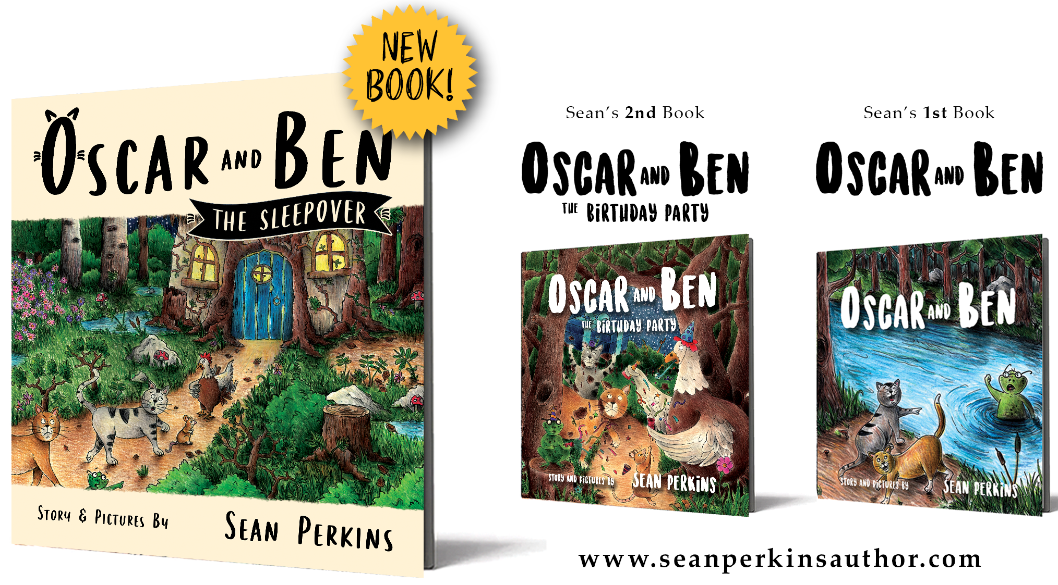

**Book Order Slip**

Child's Name (please print) ___________________________________________

Child's Teacher (please print) _________________________________________

Sean’s latest book **‘Oscar and Ben – The Sleepover’** 

Sean’s second book **‘Oscar and Ben - The Birthday Party’** 

Sean’s first book **‘Oscar and Ben’** 