25.09.24

Dear Parent/Carer,

This year, your child will have the opportunity to take part in Bikeability. We will be taking part in Bike Right sessions during Safety Week (14th - 18th October).

BikeRight will be visiting school and training our Year 5 pupils on Level 1&2 skills. They are also offering a ‘Learn to Ride’ course for those children who are non-riders. If your child is able, they will be accompanying instructors on the roads around school. If they are a ‘non-rider’, they will remain on the playground.

If you would like your child to take part, please fill in the form below indicating their skill/confidence level in riding a bike.

**If your child does not own a bike, don’t worry; BikeRight will be providing bikes and helmets. You can either bring your own, or use the ones provided.**

Yours sincerely,

Mrs D Morris

Pastoral and Safeguarding Manager

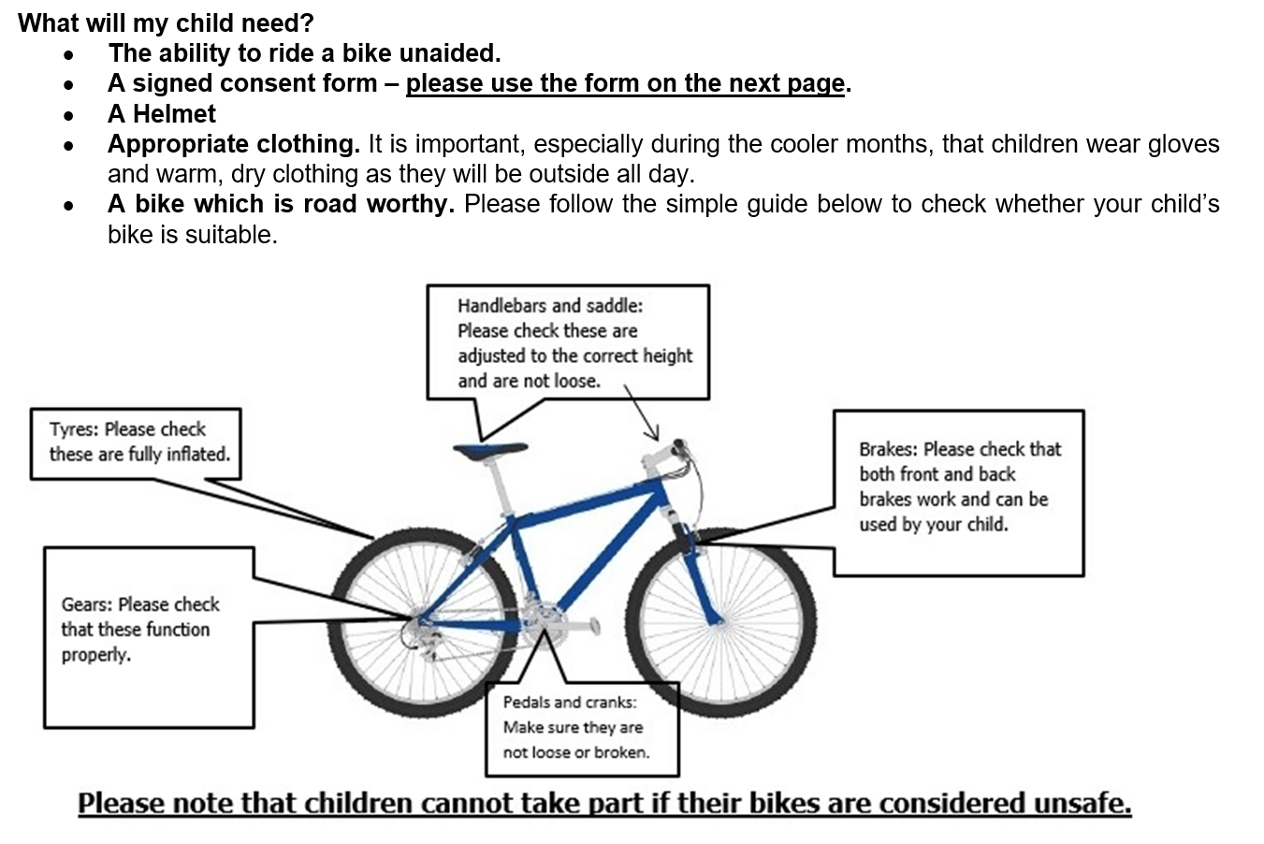

My child……………………………………………………………can take part in the Bikeability sessions.

My child is a non-rider/is not at all confident riding a bike

My child has some skills in riding a bike

My child is completely confident and independently rides a bike

Parent/carer………………………………………………………Date…………………………….

*Please return whole letter to class teacher and sign the back too*

|  |  |  |  |
| --- | --- | --- | --- |
| School Name |  | | |
| Rider Full Name |  | Age |  |
| Gender |  | Year Group |  |
| Ethnicity |  | Pupil Premium |  |
| Any special needs or medical conditions |  | | |

**TERMS & CONDITIONS FOR SCHOOL CYCLE TRAINING  
Parent / Carer please read carefully. If you agree, please sign the consent form.**

1. This consent form **MUST** be signed by the child’s parent / carer.
2. All trainees **MUST** wear an approved cycle helmet while undertaking the training and the supplied high-visibility waistcoat.
3. The instructor will determine if the trainee is able to control their bicycle sufficiently well to take part in the training.
4. Training takes place initially in the school playground. If the trainees have reached the required standard, they will then be taken out onto local roads for further on road training.
5. Training will cover all aspects of safer cycling, including recommended procedures for starting, stopping, turning left and right, developing skills and basic strategies for dealing with traffic.
6. I agree that the instructor(s) can adjust my child’s bicycle if necessary.
7. I am responsible for providing my child with suitable clothing for cycling.
8. I confirm that neither my child nor any member of my household has symptoms of COVID-19 or should be self-isolating under government guidelines
9. I agree that my child will always adhere to the protective measures set out for education settings under government guidelines, except in case of emergency
10. I will contact BikeRight! if my child develops any symptoms of COVID-19 within 48 hours of the

training session.

**I have read, understood and agree to the Terms and Conditions above**

|  |  |  |  |
| --- | --- | --- | --- |
| Name |  | Contact Number(s) |  |
| Signature |  | Date |  |

**To find out more about Bikeability:** <https://bikeability.org.uk/participants-hub/>

**Privacy and data security:**

At BikeRight! we’re committed to protecting and respecting your privacy.  
Read our Privacy policy here: <https://bikeright.co.uk/legal/privacy/>