**Tuesday 1st October**

**Attendance Update October 2024:**

Dear Parents and Carers,

School attendance is a national priority. At Parish, we recognise that positive behaviour and good attendance are essential for pupils to get the most of their school experience including their attainment, wellbeing and wider life chances.

Each week, we provide an attendance update on our newsletter now sent home on Microsoft Sway including the class attendance. Below is further information about our attendance approaches at Parish in line with updated National Guidance. More detailed information is located within our ‘Attendance and Punctuality Policy’ which is located on our school website under policies.

**Role of Parents:**

|  |  |  |
| --- | --- | --- |
| * **Make sure your child attends every day!**   ***97% is our whole school target!*** | * Notify the school as soon as possible on the first day of absence (by phoning the school office). This will be followed by a phone call if a voicemail is left. | * Try to make all medical appointments (doctors, dentist and hospital) out of school time. |
| * Discourage your child from staying overnight with friends during the week. This sometimes leads to them both being late (or not attending at all) the next day. | Talk positively about going to school. Encourage your child to take responsibility for being on time for school ensuring they have a realistic bedtime and will not be too tired to get up in the morning for school. | Work with the school and local authority to help them understand their/your barriers to attendance.  Proactively engage with the support offered to prevent the need for more formal support. |
| * If invited to attend a meeting, come and speak to us. If your child is on an attendance support plan /attendance contract, ensure they undertake the actions that have been agreed. | * Monitor your child’s internet and social media use to ensure they are not experiencing any difficulties that may prevent them from wanting to attend school. | Leave of absence during term time is not a parental right. If there are special or exceptional circumstances, please contact the Executive Headteacher and complete the correct school documentation and a decision will be made if the absence can be authorised or not. |



# Further government guidance on information around potential fines for missing school are provided through the following link: <https://educationhub.blog.gov.uk/2024/08/19/fines-for-parents-for-taking-children-out-of-school-what-you-need-to-know/>

**Our Rewards – ‘In to Win.’**

Each week, a virtual £5 is given to the class that has the highest attendance to spend on an end of term reward. This can be spent at the end of the half-term or ‘banked’ to have a big spend. Y3 (£10) and Y4 (£5) have taken an early lead but all is still to play for! You have to be ‘In to Win.’

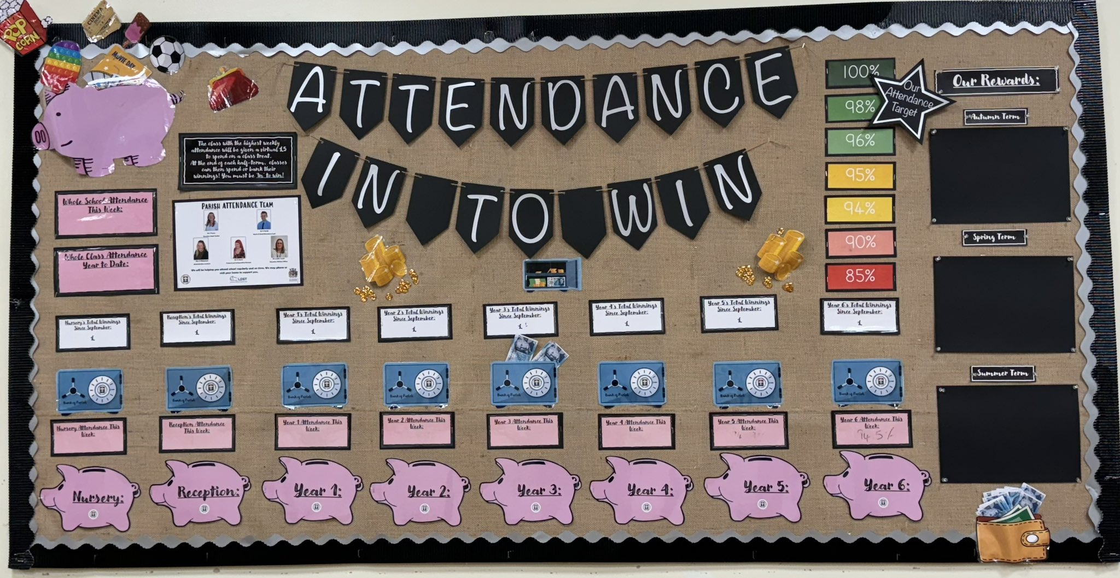

**100% Award Prize!**

At the end of the year, one child who has 100% attendance will be drawn to win a special prize of a Scooter. You will have to be in each day throughout the year to win!

**Further certificates and Incentives:**

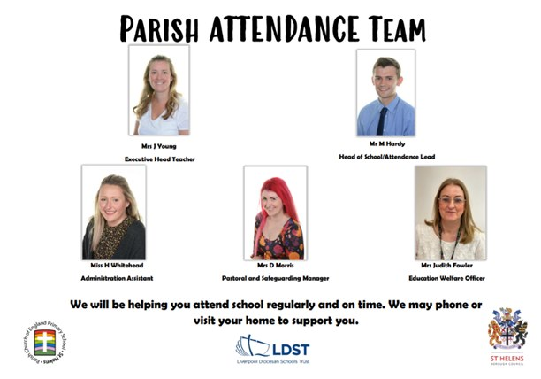Throughout the year, half-termly certificates for achieving our school target (of over 97%) are provided. This is in addition to regular dips in our prize bin and bespoke incentives that take place throughout the year.

**Parish Attendance Team:**

If you have any issues in regard to attendance, please speak to a member of the attendance team. We are always here to help.