**St Helens Descriptions of Need Document**

**2018-2022**





***Updated November 2018, this is the St Helens Thresholds of Need Document***

Effective Support for Children, Young People and Families

# Contents Page

Welcome 2

Introduction 3

Chapter 1: Description of the four levels of need 5

Chapter 2: Assessment Framework 10

Chapter 3: Indicators of need 13

Chapter 4: Support for families 22

Chapter 5: Support for staff (supervision) 23

Sources of further information 25

Bibliography 27

Acknowledgements 28

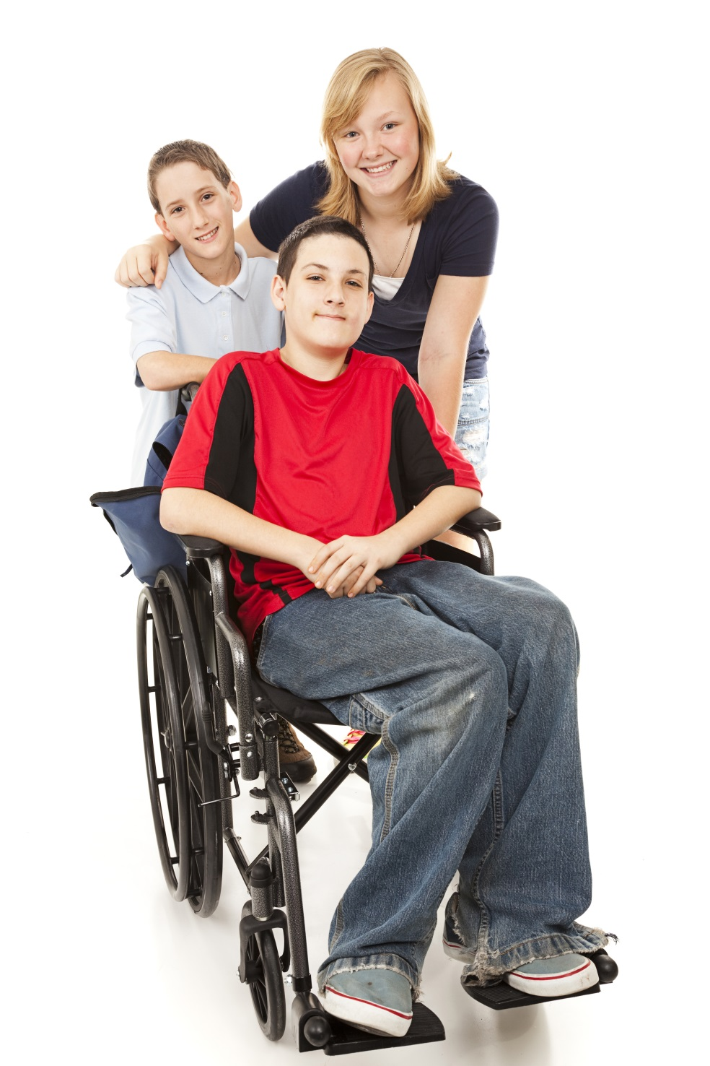

# Welcome

St Helens is committed to ensuring children, young people and their family’s needs are identified and supported when they need it, and at a level they require to enable them to thrive and be safe. The best way to achieve this is when professionals work together with families. This document was developed with the help of parents and young people who suggested we change the name of the document from ‘Thresholds of Need’ to ‘Descriptions of Need’.

In St Helens all public sector services are working together to manage the challenges of increasing costs and demand. They have collectively agreed to develop St Helens Cares, a local care system that will bring together local service providers. They will become jointly responsible for the quality and cost of care for local people, working together within agreed budgets. Effectively helping and supporting children, young people and families requires a commitment from all the agencies involved to have the same core values, knowledge, skills and ability.

The members of the St Helens Safeguarding Children Partnership are delighted that young people and parents documented their experiences of early help through multimedia and attending workshops and they have supported the writing of this document. Over 80 staff from a range of agencies actively engaged by attending workshops, sharing information about their roles and pledging to implement early help. Agencies included representatives from education, health, police, public health, social services, the community, faith and voluntary sector and youth justice.

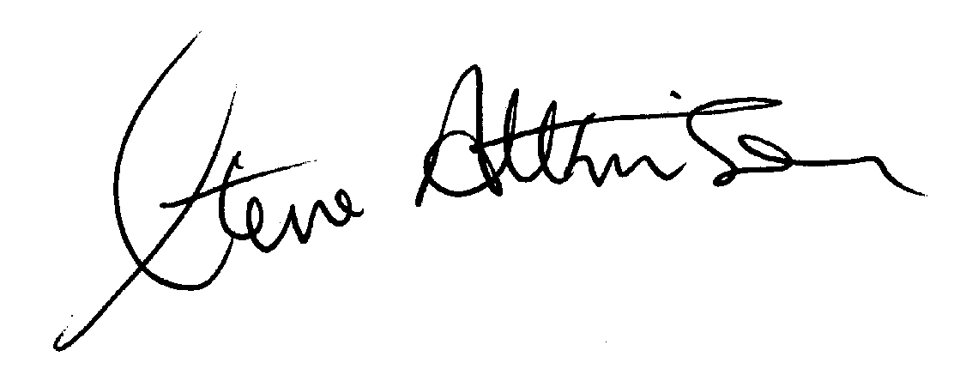

Independent Chair of the St Helens Safeguarding Children Partnership

**Young people and parents said…**

*“For young people and parents it is helpful to know the different agencies involved”*

# Introduction

It is important that children and young people in St Helens grow up feeling safe and supported and achieve their full potential throughout childhood, teenage years and into adulthood. As every child and family is unique and situations change, children, young people and their families have different levels of need which may alter over time.

The aim of this document is to provide professionals working in partnership with families to assess the level of need and to plan the offer of support, which may include more than one service. Having a thresholds document and associated guidance is a requirement of Working Together to Safeguard Children (1), which is government guidance on inter-agency working to safeguard and promote the welfare of children.

This document replaces the 2014 ‘Threshold of Need’ and ‘Continuum of Need’ documents. This document and associated guidance are set within the context of the work of the St Helens Safeguarding Children Partnership plan, the “*Think Family*” approach, and the St Helens Early Help Strategy. The *“Think Family”* approach was developed to improve the support offered to vulnerable children and adults within the same family. Individual needs are looked at in the context of the whole family, so those who use services are seen not just as individuals but as parents, carers or other family members.

All agencies and organisations in St Helens operate within the thresholds (levels) for delivery of services, working collaboratively to identify needs and provide support as soon as a problem emerges. As the level of need increases, services become increasingly targeted and specialised. There are also some differences in the processes used.

To inform any assessments undertaken at any of the levels, professionals should take into account the vulnerability within the family, the parents’/carers’ feelings about their situation, and the wishes and feelings of the children and young people.

**The purpose of this document is:**

* To provide families and professionals with a practical understanding of the thresholds of need to support professional judgement and decision making.
* To help families and professionals to better understand the services and support available across the levels of need.
* To ensure both strengths and needs are assessed and action plans are formulated and agreed.
* To encourage more professionals to feel confident to offer help at the earliest opportunity and to work closely with other agencies.
* For families to feel supported so they are encouraged and enabled to find their own solutions and be proactive in engaging with services as required.

**The four levels of need are:**

* **Level 1 – Universal**: Children and young people, including those with needs, whose needs are met by family, community and universally provided services.
* **Level 2 – Early Help:** Children may have low levels of need or be susceptible to poor outcomes and would benefit from additional support and services to help them overcome difficulties.
* **Level 3 – Child in Need:** Children have a higher or more complex level of need requiring a multi-agency response, offering targeted support to improve outcomes. Children at this level meet the legal threshold for a child in need assessment (Section 17) and should be referred to Contact Cares using a service request form to [adultandchildrenteam@sthelens.gov.uk](mailto:adultandchildrenteam@sthelens.gov.uk).

The Contact Cares Team should only be alerted via phone calls if concerns relate to level 4.

* **Level 4 – Child Protection:** Children or young people who are experiencing very serious or complex needs that are having a major impact on their achievement of expected outcomes. Their needs will be such that they require intensive support from specialist services. Children at this level meet the statutory threshold for child protection (Section 47 (1)) and should be referred to Contact Cares, telephone number 01744 676600.

This document includes a summary of the thresholds (levels), a description of the thresholds of need and the processes used, and the Assessment Framework, which is used to outline the indicators of need. This is followed by chapters on support for families and professionals and useful sources of further information.

**A parent said about Early Help…**

*“It’s about the people who give early help knowing what to do”*

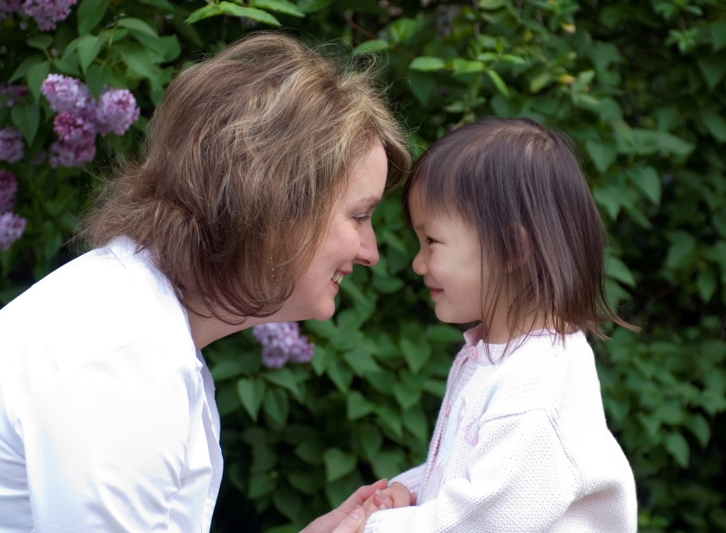

# Chapter 1: Description of the four levels of need

The four levels of need are summarised in the diagram below. The descriptors of the thresholds (levels) are intended to help decision making in relation to considering levels of need and strengths; they should not be viewed as a replacement for professional judgement and line management advice. The levels are a guide; the needs of children, young people and families do not easily fit into categories or boxes.

Diagram 1: Summary of the four levels of need

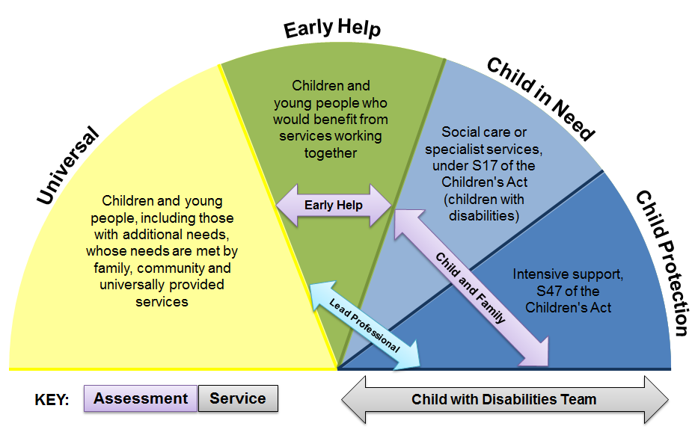

When using the descriptors, practitioners must consider a number of different risk factors and their impact. For example, there may be a child whose needs are in the main met, however the presence of a specific risk factor may lead the professional to consider that a specialist assessment is required. Professionals must consider the negative impact on the child or young person when a set of risk factors have been present for an extended time period. The number and length of time risk factors are present has a multiplication (cumulative) effect. Analysis of the available information and observations should inform next steps in relation to the child’s/children’s plan, and timescales for the plan to be implemented.

Research and experience indicate that very young babies are extremely vulnerable and that work carried out in the antenatal period to assess risk and to plan intervention will help to minimise harm. For more information see the St Helens Multi-Agency Pre-Birth Protocol (see sources of further information).

For children with Special Educational Needs and Disability (SEND), schools and other professionals should refer to the SEN Code of Practice, which references the need for a graduated approach (2).

A description of each level follows in the tables on the next few pages. Where there is identified harm or at risk of suffering significant harm, children’s social care should be contacted immediately via Contact Cares on 01744 676600.

All professionals across the borough working with children, young people and families need to know how to escalate a case where they are worried that professionals are not working well together and as a result a child is not making good enough progress or is at risk. St Helens has a resolution policy (which replaces the escalation policy) and a complaints policy; see sources of further information’.

| **Table: Description of the four levels of need** | |
| --- | --- |
| **Level 1: Universal** | |
| Definition | * Children and young people, including those with additional needs, whose needs are met by family, community and universally, provided services. * Universal services have long(er) term involvement with children and families and play a key role in helping them throughout stages of life. Services are encouraged to help and support children and families to resolve need at this level. * All services should help support children and families to find their own solutions. * Sometimes children and families need more structured and focused help, for example, when they are going through challenging times. One professional may be able to provide the extra help that is needed, or help the family to identify where to access the right help. |
| Example | * Children and young people, who reach their full potential, make good overall progress through the care of their families, communities and the support of a range of universally provided services; this could include welfare rights and debt management, health issues or behaviour management strategies in the home. * For instance a school nurse or learning mentor is encouraged to offer support where they can, and where formal assessment and planning is not required. |
| Process | * Each agency uses its own processes and documentation. * This is to include a plan that is co-developed with families and monitored to see if the plan has been implemented and agreed outcomes have been achieved and, if not, what the next steps are. * The Early Help Assessment Tool (EHAT) checklist is available to support the consideration of information available and the agreed plan. * All schools should have a clear approach to identifying and responding to special educational need, the first response should be high quality first teaching (3). |
| Consent | * Each agency will have its own process for gaining and documenting consent. * Article 8 of the Human Rights Act 1998 states that everyone has the right to respect for his or her private and family life, home and correspondence. Workers who have access to information about children and families must therefore treat any information as confidential. * When an individual agency identifies needs that cannot be met by their service alone, consent to refer to an appropriate service should be obtained from parents or carers. |
| Lead professional | * Not required. |
| Definitions used by other services | * Example from 0-19: Universal services from the health visitor and school nurse ensure that families can access the healthy child programme, are supported at key times and have access to a range of community services (4). |
| Information sharing | * It is important to keep accurate and reliable records so that if required, information can be shared appropriately and lawfully (providing there is the appropriate consent). |

| **Level 2: Early Help** | |
| --- | --- |
| Definition | * Children may have low levels of need or may be vulnerable to poor outcomes and require additional support and services to help them overcome any difficulties. Early Help can also prevent problems arising. * Effective early help relies upon local agencies working together to: identify children, unborn babies included, and families who would benefit from early help; undertake an assessment of the need for early help; and provide targeted early help services to address the assessed needs of a child and their family, which focuses on activity to significantly improve the outcomes for the child. * Providing early help is more effective in promoting the welfare of children than reacting later. Early help means providing support as soon as a problem emerges, at any point in a child's life, from the unborn through to the teenage years. |
| Example | * There may be concern about a number of risk factors or one specific risk factor. * The family either require additional support over and above universal services (level 1) or may have improved and no longer be at level 3 or 4. * The threshold for statutory social care intervention is not currently met. |
| Process | * Local authorities, under section 10 of the Children Act 2004, have a responsibility to promote inter-agency cooperation to improve the welfare of children. * The assessment and recording are supported by the Early Help Assessment Tool. * The procedure is ‘Think Family’ (5). * Additional support for the plan can be gained via the Level 2 Panel (5). * Consider targeted interventions as part of the graduated response to SEND (3). |
| Consent | * The consent of parents and young people of sufficient age and understanding is therefore required for agencies to share information or to hold a Family Action Meeting. * Agencies should obtain consent to start the Early Help Assessment and begin to coordinate a plan of support. * The Think Family Multi Agency Consent Form should be used to record consent to information sharing. The consent statement on the Early Help Assessment Tool system should be updated to include all agencies that are supporting the family. * Unless there are very exceptional circumstances, meetings should not take place without the consent of parents and children of sufficient age and understanding. See the Think Family procedure for more information (5). |
| Lead professional | * A lead professional is identified from amongst the group of practitioners working with the unborn, child, young person or family. The lead professional is chosen through a process of discussion and agreement between those practitioners who are involved and in consultation with the family. * If the case is referred to the Level 2 Panel and assigned a Family Intervention Worker, the lead professional will be informed of the outcome of panel and the recommended plan. The lead professional and allocated Family Intervention Worker should meet within 5 working days to agree a plan of work. |
| Definitions used by local services | * Example from youth justice: Prevention service: providing intervention to young people and their families who are identified at early onset of risk of offending or displaying antisocial behaviour in the community. |
| Information sharing | * Effective sharing of information between professionals and local agencies is for effective identification, assessment and service provision. Participants attending the Family Action Meeting will share information documented within their report and relevant to the dimensions and domains of the Assessment Framework outlined in the Early Help Assessment Tool. |
| **Level 3: Child in Need** | |
| Definition | * Where there are more complex needs, help may be provided under section 17 of the Children Act 1989 (Child in Need). * Children have a higher or more complex level of need requiring a multi-agency response offering targeted support to improve outcomes. * A child in need is defined under the Children Act 1989 as a child who is unlikely to achieve or maintain a reasonable level of health or development, or whose health and development is likely to be significantly or further impaired, without the provision of services; or a child who is disabled. |
| Example | * Children in need may be assessed under section 17 of the Children Act 1989, in relation to their special educational needs, disabilities, as a carer, or because they have committed a crime. * Where concerns escalate beyond early help, and significant harm is likely or a child’s level of development/welfare is compromised, the concern can be ‘stepped up’ for social care interventions where appropriate (6). * Similarly, where there has been social care interventions, and needs have been addressed, it can be ‘stepped down’ to ensure continuation of support that is appropriately provided through multi-agency arrangements, which should prevent re-escalation at a later stage (6). |
| Process | * Child in Need (CiN). * Referrals are made using the Service Request Form which is sent to the Contact Centre on [adultandchildrenteam@sthelens.gov.uk](mailto:adultandchildrenteam@sthelens.gov.uk). Parents/carers consent needs to be sought before completing this. Once the service request form is received, screening is completed by the Front Door Team and a decision is made as to whether to progress to the Statutory Assessment Team for a Children and Families Assessment. * Consider targeted interventions as part of the graduated response to SEND, additional funding may be required. Learners necessitating long term interventions with personalised learning may require an Education, Health and Care (EHC) plan (3) and/or a Care, Education and Treatment Review (CETR) for a child or young person at risk of admission to, or who is already in, a specialist learning disability or mental health hospital (7). |
| Consent | * The consent of parents and young people of sufficient age and understanding is required for agencies to share information or to hold a multiagency meeting. * Unless there are very exceptional circumstances, meetings should not take place without the consent of parents and children of sufficient age and understanding. * If parents or young people choose not to consent it may raise questions as to why. If parents or young people are worried or not sure, they should be encouraged to speak to the professional(s) working with them about their concerns. * The Multi Agency Consent Form should be used to record consent to information sharing. * A Service Request Form should be completed. |
| Lead professional | * The assessment is completed by a social worker; the lead professional is usually a social worker but can be one of the other services/agencies working closely with the family. |
| Definitions used by other services | * The same statutory (legal) definition is used by all services. |
| Information sharing | * The same as for Early Help * Effective sharing of information between professionals and local agencies is for identification, assessment and service provision. Meeting participants will share information documented within their report for a Child in Need Meeting and relevant to the dimensions and domains of the Assessment Framework. |

|  |  |
| --- | --- |
| **Level 4: Child Protection** | |
| Definition | * The Children Act 1989 introduced significant harm as the threshold that justifies compulsory intervention in family life and the best interests of the children. * Local authorities have a duty to make enquiries under Section 47 of the Children Act 1989 if they have ‘reasonable cause to suspect that a child is suffering or likely to suffer significant harm’. * Children or young people who are experiencing very serious or complex needs that are having a major impact on their achievement of expected outcomes. Their needs will be such that they require intensive support from specialist services. * Neglect is the ongoing failure to meet a child's basic needs and is the most common form of child abuse. |
| Example | * Concerns about maltreatment may be the reason for a referral to local authority children’s social work service or may arise during the course of providing social work services to the child and family. * Cases of physical, sexual or emotional harm or where the child/children are experiencing neglect, or have been the perpetrator or victim of a serious crime. |
| Process | * Referral is made to Contact Cares; telephone number 01744 676600. Screening is completed by the Front Door Team. The case information is sent to statutory services for a Strategy Meeting to determine if Section 47 threshold is met. * If the case is already open at Level 3, escalation is via internal processes. * The Single Assessment is completed by a social worker. |
| Consent | * Consent should always be gained from the parent unless informing the parent or person with parental responsibility would put the child or young person at further risk. |
| Lead professional | * A social worker will be the lead professional. |
| Definitions used by other services | * The same statutory definition is used by all services. * Other useful definitions:   + Section 20: Some children may require accommodation because there is no one who has parental responsibility for them, because they are lost or abandoned or because the person who has been caring for them is prevented from providing them with suitable accommodation or care. Under section 20 of the Children Act, the local authority has a duty to accommodate such children in their area (1). Children remanded (pre-sentencing) to a Youth Detention Centre automatically come under section 20 until or unless sentenced to custody. The Social Worker and Youth Justice Worker work collaboratively to schedule reviews (1).   + Section 31: where a child is in the care of the local authority, the local authority, as a corporate parent, must assess the child’s needs and draw up a care plan which sets out the services which will be provided to meet the child’s identified needs (1). |
| Information sharing | * Effective sharing of information between professionals and local agencies is essential for identification, assessment and service provision. * Meeting participants will be expected to provide information to a Strategy Discussion/Meeting and any subsequent Child in Need Meeting or Child Protection Case Conference/Core Groups. Any information unless confidential should be disclosed to parents. * Information contained in the Child and Family Assessment, should be across the dimensions and domains of the Assessment Framework outlined in the Children & Families Assessment. |

# Chapter 2: Assessment

Research has shown that taking a systematic approach using a clear framework is the best way to deliver a comprehensive assessment for all children (1). At whatever level an assessment is being completed, the purpose of the assessment is to gather information, analyse need, assess risk, and decide on appropriate actions to improve the child’s outcomes. The Framework of Assessment of Children in Need and their Families provides a systematic basis for collecting and analysing information to support professional judgements about how to help children and families in the best interests of the child (8).

A good assessment is one which investigates the following three domains, see diagram 2 below:

* The child’s developmental needs considering adverse childhood experiences and trauma, also including whether they are suffering, or likely to suffer, significant harm
* Parents’ or carers’ capacity to respond to those needs
* The impact and influence of wider family, community and environmental factors

Diagram 2: Assessment Framework

In making a professional judgement about level of need there are a number of key questions that should be given consideration:

* What is the evidence of impact on the child, in relation to their health and development or harm/likely harm?
* What is the evidence of impact on the unborn baby in relation to their health and development or harm/likely harm?
* What are the risks to the child if things do not change?
* What are the individual needs and views of each child in the family?
* What does the family’s history tell us in respect of level of need, ability to engage, to make and sustain change, ability to work openly and honestly with involved professionals?
* What services or work has already been undertaken with the family and what impact has this had?
* Does the child receive specific support at school which indicates a Special Educational Need?

The Signs of Safety model is designed to help practitioners with risk assessment and safety planning; it has four key questions (9):

* What are we worried/concerned about?
* What’s working well?
* How worried/concerned are we?
* What needs to happen?

Risk assessment is the process of estimating and evaluating risk. Professionals must continually assess risk, during and after every successive contact. Risk assessment tools aid professionals to identify the likelihood and the severity of risk. All professionals are responsible for acting in accordance with the level of risk they have identified and following due process and organisational procedure. At the time of writing this document, we are updating our approach to risk assessment based on Signs of Safety and further guidance will be made available in due course. All risk assessment tools have limitations and are an aid to, not a replacement for, professional judgement. Below is an example of risk assessment based on Signs of Safety:

|  |  |  |
| --- | --- | --- |
| **Example risk assessment tool based on Signs of Safety** | | |
| **What are we worried about?** | **What is working well?** | **What needs to happen?** |
| Past harm (severity, frequency, length of time, impact)  Future harm (worries for the future if nothing changes)  Complicating factors (factors that make the situation more difficult to resolve) | Existing strengths  Existing safety/protection (strengths which demonstrate protection from danger over time) | Future safety/protection (what must the caregivers do to address the future danger)  What does the family want generally an in relation to safety?  Next Steps / Immediate progress |
| **Harm to Safe Continuum**  **0 10**  On a scale of 0 to 10 where 0 means things are so bad that the child(ren) cannot live at home and 10 means the child is safe, where do you rate the situation? (If peoples judgment differ, place different peoples number on the continuum) | | |

Graded Care Profile 2 (GCP2) helps professionals measure the quality of care being given to a child. The GCP2 is included in the Early Help Assessment Tool and the Child and Family Assessment. It is an assessment tool that helps professionals to spot anything that's putting that child at risk of harm. It is called Graded Care Profile 2 (GCP2) because different aspects of family life are 'graded' on a scale of 1 to 5.

Questions are broken down into 4 areas:

1. Physical, such as quality of food, clothes and health
2. Safety, such as how safe the home is and if the child knows about things like road safety
3. Emotional, such as the relationship between the carer and child
4. Developmental, such as if a child is encouraged to learn and if they are praised for doing something good (10)

It is important professionals are honest and respectful when completing any assessments with the family taking into account culture and family values, the strengths within the family system and building on these to develop sustainable change.

High quality assessments:

* Are child centred; where there is a conflict of interest, decisions should be made in the child’s best interests
* Are rooted in child development and informed by evidence
* Are focused on action and outcomes for children
* Are holistic in approach, addressing the child’s needs within their family and wider community
* Ensure equality of opportunity
* Involve children and families and take a whole family approach
* Build on strengths as well as identifying difficulties
* Are integrated in approach
* Are a continuing process not an event
* Lead to action, including the provision of services
* Review services provided on an ongoing basis
* Are transparent and open to challenge

The next chapter uses the three domains of the Framework of Assessment and the elements within the domains to aid professional judgement to determine at which level of need a child is at.

# Chapter 3: Indicators of need

The indicators of need are intended to aid decision making in relation to considering levels of need and strengths, they are not a replacement for professional judgement and line management advice (6). The levels (thresholds) are a guide; the needs of children, young people and families do not easily fit into categories or boxes. Professionals need to consider both the number of risk factors and the length of time they have been present.

When there is an immediate need to protect a child because they are being harmed or are at risk of harm the practitioner must contact the Local Authority Children’s Social Care and/or police directly and make a telephone referral (Contact Cares 01744 676600). All practitioners must follow the prescribed referral process.

## Level 1: Universal

|  |  |  |
| --- | --- | --- |
| **Element** | **Indicators** | **Key Services** |
| **Child’s Developmental Needs** | | |
| Health | * Routine health appointments attended, early booking for pregnancy * Regular dental/optical care * Good diet and exercise * Developmental checks/immunisations up to date * Speech and language development met * Development milestones and motor skills * Sexual activity age appropriate * Good mental health | Schools  Children’s Centres  Early Years providers  Midwives  Health Visitors  School Nurses  GPs  Public Health Nurses  Play Services  Youth Services  Police  Housing  Libraries  Family information Service  Healthy Living Team |
| Education | * Enjoys and participates in learning activities * Has experiences of success and achievement * Access to books and toys, play * Choices and encouragement * Sound links between home and school * Planning for career and adult life |
| Emotional and Behavioural Development | * Feelings/actions demonstrate appropriate responses * Good quality early attachment * Able to adapt to change * Able to understand others’ feelings * Takes responsibility for behaviour * Responds appropriately to boundaries and constructive guidance |
| Identity | * Sense of self * Ability to express needs * Positive sense of self and abilities |
| Family and Social Relationships | * Stable and affectionate relationships with family * Is able to make and maintain friendships |
| Social Presentation | * Good hygiene, appropriately dressed |
| Self-Care Skills | * Growing level of competencies in practical and emotional skills such as feeding, dressing and independent living skills |
| **Parenting Capacity** | | |
| Basic Care | * Provides for child’s physical needs e.g. food, drink, appropriate clothing, medical and dental care | Infant Feeding Team  Voluntary and Community Sector |
| Ensuring Safety | * Protects from danger or significant harm in the home and elsewhere * Restricts/monitors internet access * Takes reasonable steps in pregnancy to ensure own safety |
| Emotional Warmth | * Demonstrated positive feeling towards the unborn * Facilitates cognitive development through interaction and play * Consistency of emotional warmth over time |
| Stimulation | * Facilitates cognitive development through interaction and play * Enables child to experience success |
| Guidance and Boundaries | * Provide guidance so that the child can develop a sense of right and wrong * Ensures child accesses formal education available to them |
| Stability | * Ensures that secure attachments are not disrupted |
| **Family and Environmental Factors** | | |
| Family History and Functioning | * Good relationships with caregivers and siblings * Affectionate with care givers * Demonstrates feelings of belonging and acceptance * Few significant changes in family composition |  |
| Wider Family | * Positive relationships with peers * Sense of larger familial network/good friendships outside of the family unit |
| Housing | * Accommodation has basic amenities and appropriate facilities * Adequate furnishings and belongings |
| Employment | * Working or in receipt of appropriate benefits |
| Income | * Managing budget to meet individual needs |
| Family’s Social Integration | * Family feels part of the community |
| Community Resources | * Access to good universal services in the community |

## Level 2 – Early Help

|  |  |  |
| --- | --- | --- |
| **Element** | **Indicators** | **Key Services** |
| **Child’s Developmental Needs** | | |
| Health | * Late booking for antenatal care, some missed antenatal appointments * Foetal anomalies noted in pregnancy indicating possible complex health needs * Maternal drug or alcohol use in pregnancy * Maternal mental health problems noted in pregnancy * Teenage pregnancy (dependant on age and support required) * Non-attendance for developmental checks and immunisation appointments * Some missed health appointments * Early indicators of developmental delay * Low level experimental drug and alcohol misuse * Smoking * Low risk sexualised behaviour * Chronic health condition (e.g. diabetes, epilepsy) | **Level 1 Universal services plus:**  Alcohol and Drug Treatment Services  Child and Adolescent Mental Health Services (CAMHS)  Community Paediatrics Service  Early Help Team, Level 2 Panel  Education Welfare  Family Nurse Partnership  Paediatric Continence Team  Psychology  Sexual Health Services  Speech and Language Therapy Service  Specialist Midwives  St Helens Young Carers  Youth Justice Service |
| Education | * Some identified learning or physical disability needs, requiring support * Poor punctuality * Pattern of school absences * Not always engaged in learning – poor concentration/low motivation/interest * Not reaching educational potential * Limited access to books/toys * Number of school moves * Language and communication difficulties * Not in post 16 education/employment or training |
| Emotional and Behavioural Development | * Concern about developmental progress e.g. underweight/overweight/bedwetting/soiling * Self-harm (including substance misuse) * Some evidence of inappropriate responses and actions * Can find managing change difficult * Starting to show difficulties expressing empathy * Feelings: grievance/injustice/oppression |
| Identity | * Some insecurities around identity expressed * Low self-esteem/self-confidence, feelings of worthlessness * May be affected by peer/gang pressure * Unsure or unable to disclose sexual orientation * Strong negative gender identification and roles * Unexplained change in peer group – can be dominated |
| Family and Social Relationships | * Vulnerable to emotional difficulties perhaps in response to life events such as parental separation e.g. child seems unduly anxious, angry or defiant for their age * Some difficulties with peer group relationships and adults * May experience bullying around “differences” * Self-isolation from family * May have a caring role for a family member which is affecting their education, health or social life |
| Social Presentation | * Can be over-friendly or withdrawn with strangers * Can be provocative in appearance and behaviour |
| Self-Care Skills | * Not always adequate self-care e.g. poor hygiene, self-neglect * Slow to develop age-appropriate self-care skills |
| **Parenting Capacity** | | |
| Basic Care | * Engagement with services is poor * Requires advice on parenting issues * Professionals are beginning to have concerns as to whether a child’s physical needs are being met * Little preparation for parenthood * Minor concerns re: diet/hygiene/lack of sleep |  |
| Ensuring Safety | * Frequent accidents * Parental decisions affecting child safety * Parental stresses starting to affect ability to ensure child’s safety * Some exposure to dangerous situations in the home or community including online violent and/or extremist websites or influencers |
| Emotional Warmth | * Inconsistent responses to child by parent(s) * Some negative feelings about the pregnancy |
| Stimulation | * Low self-esteem for learning * Spends considerable time alone e.g. watching television/computer games * Child is not often exposed to new experiences |
| Guidance and Boundaries | * Parent/carer offers inconsistent or distorted perspective of boundaries * Responds inappropriately to boundaries/constructive guidance * Can behave in an anti-social way in the neighbourhood e.g. petty crime |
| Stability | * Parents fail to challenge extremist viewpoint * Lack of routine in the home * Key relationships with family members not always maintained * Unstable family environment * Multiple changes of address |
| **Family and Environmental Factors** | | |
| Family History and Functioning | * Parents have some conflicts or difficulties that can involve the children * Has experienced loss of significant adult e.g. through bereavement or separation * Parent has physical or mental health issues * History of abuse * Child to adult abuse * Parents ability to cope with needs of disabled child * Family history of criminal gang involvement * Family attitudes that rationalize or minimise offending * Female genital mutilation, forced marriage or honour based violence * Signs of being bullied * Some support from friends and family * Caring responsibilities * Child depressed, alone, anxious or feeling unhappy/misunderstood * A child/young person is taking on a caring role in relation to their parent/carer, or is looking after younger siblings |  |
| Wider Family | * Extended family live in areas of conflict * Family religious/cultural beliefs negatively affect role and responsibilities of child * Age inappropriate relationships |
| Housing | * Inadequate/poor housing * Rent arrears put family at risk of eviction or proceedings initiated * Risk of becoming homeless in the future but where the threat of homelessness is not immediate |
| Employment | * Periods of unemployment of the wage earning parent(s) * Parents have limited formal education * Parents starting to feel stressed around unemployment or working situation * Barriers to employment opportunities |
| Income | * Low income * Financial/debt difficulties |
| Family’s Social Integration | * Family may be new to the area * Some social exclusion experiences * Negative influences from peer groups or friends * Marginalised from community |
| Community Resources | * Family struggling to access universal services |

## Level 3 – Child in Need

|  |  |  |
| --- | --- | --- |
| **Element** | **Indicators** | **Key Services** |
| **Child’s Developmental Needs** | | |
| Health | * Non engagement in antenatal care * Significant maternal drug or alcohol use in pregnancy, poor engagement with services * Significant maternal mental health problems noted in pregnancy, poor engagement with services * Recurrent missed health appointments * Diagnosis of significant development delay/ multiple/complex needs * Concerns about diet and weight not being addressed * Chronic health condition, non-compliance with care plan * Life limiting condition * Palliative/end of life care * Increasing mental health problems, self-harm, suicide attempts * Recurrent sexually transmitted infections, multiple partners, requests for emergency contraception * Increased number of attendances with drug and alcohol related issues * Harmful sexual behaviour, medium risk | **Level 1 Universal and Level 2 Early Help services plus:**  Acute Paediatrics Service  Children’s Social Care  Children’s Community Service  SEN Services, Specialist Health or Disability Services  Youth Justice Service  Targeted Drug and Alcohol Support Services  Targeted Early Help, including Children’s Centres  Family Support Services  Family Nurse Partnership  Targeted Sexual Health Services  Voluntary and Community Services |
| Education | * Significant learning needs and may have Statement or Educational Needs (orEducation Health and Care Plan) * Poor school attendance and punctuality * Some fixed term exclusions * Not engaged in education or reaching educational potential |
| Emotional and Behavioural Development | * Finds it difficult to cope with anger, frustration and upset * Disruptive/challenging behaviour at school or in community * Cannot manage change * Unable to demonstrate empathy * Repeated episodes of self-harm and/or substance misuse |
| Identity | * Demonstrates significantly low self-esteem in a range of situations * Serious negative belief systems about gender * Marginalised/over identification with group or ideology * Little social relationships outside the home |
| Family and Social Relationships | * Is subject to discrimination e.g. racial, sexual orientation or disabilities * Is subject to peer/gang pressure * Peers also involved in challenging behaviour * Regularly needed to care for another family member * Known gang involvement * Access to extremist networks |
| Social Presentation | * Is provocative in behaviour/appearance * Clothing is regularly unwashed * Hygiene problems * Sudden display of unexplained gifts/clothing * Attitudes justify offending * Intolerant of others’ views – resulting in de-humanising of perceived enemies |
| Self-Care Skills | * Poor or inappropriate self-care for age, including hygiene |
| **Parenting Capacity** | | |
| Basic Care | * Struggling to provide adequate care * Previously looked after by local authority * Child sentenced to custody / placed in a Secure Environment * Professionals have serious concerns e.g. parental drug/alcohol misuse * No preparation for parenthood |  |
| Ensuring Safety | * Child perceived to be a problem by parents * May be subject to neglect * Parents hold extremist views and condone extremist behaviours |
| Emotional Warmth | * Receives erratic or inconsistent care * Instability affects capacity to nurture * Has no other positive relationships * Unwanted pregnancy |
| Stimulation | * Not receiving positive stimulation, with lack of new experiences or activities * Deliberate restricting access to positive activities and experiences |
| Guidance and Boundaries | * Erratic/inadequate guidance provided * Parent not offering good role model e.g. behaving in an anti-social way * Parents enforcing unrealistic boundaries and guidance * No restrictions imposed re. access to extreme sites/groups |
| Stability | * Has multiple carers * Limited attachments that are controlled by parents |
| **Family and Environmental Factors** | | |
| Family History and Functioning | * Incidents of domestic violence between parents * Acrimonious divorce/separation * Family have serious physical and mental health difficulties * Family associated with extremist group/ideology |  |
| Wider Family | * Family has poor relationship with extended family/little communication * Caring responsibilities with no agency support * Parents influenced by negative family, community, cultural, religious beliefs and practices * Access to extremist networks * Over identification with group/ideology |
| Housing | * Poor state of repair, temporary or overcrowded * Homeless, living in hostel * A young person aged 16 or 17 who appears to be homeless or threatened with homelessness Exposure to victimisation/racism |
| Employment | * Parents experience stress due to unemployment or “overworking” * Parents find it difficult to obtain employment due to poor/basic skills |
| Income | * Serious debts/poverty impact on ability to meet basic needs |
| Family’s Social Integration | * Parents socially excluded * Lack of support networks * Associating with young people who are sexually exploited * Negative support networks |
| Community Resources | * Poor quality universal resources and access problems to these and targeted services |

## Level 4 – Child Protection

|  |  |  |
| --- | --- | --- |
| **Element** | **Indicators** | **Key Services** |
| **Child’s Developmental Needs** | | |
| Health | * Concealed pregnancy * Non accidental or unexplained physical injury * Bruising in non-mobile child * Sexual activity/pregnancy in under 13 * Allegation of physical/sexual abuse * Fabricated induced illness, significant risk identified following instigation of protocol * Significant mental health problems, multiple or significant suicide attempts * Significant health concern associated to drug or alcohol misuse * Significant health concern associated with non-attendance/non-compliance * Harmful sexual behaviour, high risk * Actively subverting weight management initiatives | **Level 1 Universal, Level 2 Early Help and Level 3 Child in Need services plus:**  Statutory Children’s Social Care Services  Specialist Looked After Children Services |
| Education | * Out of school * Permanently excluded from school or at risk of permanent exclusion * No access to leisure activities |
| Emotional and Behavioural Development | * Regularly involved in anti-social/criminal activities * Puts self or others in danger e.g. missing from home or in care * Suicide attempts * Children at risk of sexual exploitation * Harmful sexual behaviour * Early onset of drug use |
| Identity | * Involved in manipulation and coercion of others * Manipulation and coercion into negative cultural, religious activities * Experiences persistent discrimination in relation to race, sexual orientation, gender, religion or disability |
| Family and Social Relationships | * Periods of being accommodated by the Local Authority * Family breakdown related in some way to child’s behavioural difficulties * Subject to physical, emotional or sexual abuse or neglect * Main carer for family member * Where parents have made private fostering arrangements |
| Social Presentation | * Involved with organised gangs or criminal activity * Discriminating on grounds of race, sexual orientation, gender, religious identity and/or disability |  |
| Self-Care Skills | * Neglects to use self-care skills. For example, due to alternative priorities e.g. substance misuse |
| **Parenting Capacity** | | |
| Basic Care | * Unable to provide “good enough” parenting that is adequate and safe including unborn child * Mental health problems/substance misuse significantly affects care of child * Parents unable to care for previous children * Parents support and encourage extremist ideology * Parents involved in drug dealing or other criminal activity |  |
| Ensuring Safety | * Instability/violence in the home continually * Parent normalises situations of risk * Parents involved in crime * Parents unable to keep child safe * Victim of crime * Travel to areas of conflict * Engagement with extremist activity * Subject to traditional unsafe practices (e.g. female genital mutilation) |
| Emotional Warmth | * Forced marriage, honour based violence * Parents inconsistent, highly critical or apathetic towards child * Unwanted pregnancy |
| Stimulation | * No constructive leisure time or guided play * Encouraged to view/promote extremist ideology * Positively denying access to positive activities and experiences |
| Guidance and Boundaries | * No effective boundaries set * Regularly behaves in an anti-social way in the community * Exposure to extremist influences * Exhibiting behaviours to manage unrealistic and negative boundaries * Beyond parental control |
| Stability | * Has no-one to care for child * Concerns regarding family travel to areas of conflict * Engagement in extremist activity * Relationships and attachments based on negative influences |
| **Family and Environmental Factors** | | |
| Family History and Functioning | * Unaccompanied asylum seeker * Family relationships impose negative influence * Significant parental discord and persistent domestic violence * Poor relationships between siblings * Family member has terrorism conviction * Family member is known to be a significant risk to children * Parents negative cultural, religious beliefs and practices |  |
| Wider Family | * No effective support from extended family * Destructive/unhelpful involvement from extended family * Intention to travel to area of conflict * Engagement in terrorist activity |
| Housing | * Physical accommodation places child/unborn in danger * Homelessness, ‘sofa surfing’ |
| Employment | * Chronic unemployment, severely affecting parent’s own identity * Unable to gain employment due to lack of basic skills or long-term difficulties e.g. substance misuse |
| Income | * Extreme poverty/debt impacting on ability to care for child * At risk of financial exploitation * Young person with access to an inexplicable large amount of money |
| Family’s Social Integration | * Family chronically socially excluded * No supportive network * Family members associated with extremist views * Family coerced into acts of abuse |
| Community Resources | * Poor quality services with long-term difficulties with accessing target populations |

# Chapter 4: Support for families

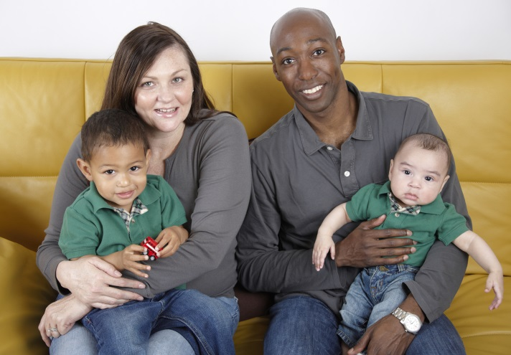A positive partnership between parents and agencies is a fundamental principle underpinning the successful promotion of children’s welfare and the protection of children. However, parents may need independent support, information and advice to be able to participate fully in the system processes from an informed position, particularly where there is a divergence of views. Parents will be treated equally and without discrimination. This is regardless of the individual’s ethnic background, language, culture, faith, gender, age, sexual orientation or any other aspect that could result in them being discriminated against (5).

Arrangements can be made, for example in Family Action or Child in Need Meetings, for parents/carers and children to be accompanied by an advocate or supporter if they choose or if they need independent support because of their vulnerability or having additional needs (5).

An advocate is generally someone employed by an advocacy organisation or a specialist solicitor without personal involvement with the service user. Examples of advocacy organisations include: the National Youth Advocacy Service for young people; St Helens Information Advice and Support Service (IASS) for parent/carers; and N-Compass Advocacy Service (NYAS) for mental health. The role of the child’s advocate is distinct from that of the parent’s advocate as they each represent the views of their own client. A supporter will have an informal relationship with the service user such as friend, relative or member of a self-help group.

The goal of advocacy is:

* To empower parents and children to participate in the process from an informed position
* To promote good communication between parents, children and professionals

## Feedback from parents and young people

During the workshops, parents and young people were asked for their views on Early Help and they said:

* **Overcoming stigma:** being referred to social services can make you feel like you are a ‘bad parent’, Early Help is voluntarily entered into and parents need to be able understand what Early Help is and that it is supportive and enabling.
* **Consistent support:** sometimes families go up or down a level or cross from one threshold (level) to another. However, because the threshold has changed, it does not automatically mean that the parent feels any different. Thus it needs to be made clear ‘what happens now’ and ‘where can I get support if I need it’.
* **Achievable goals:** It can be distressing for a parent or family to have a service ‘come in’; there can be feelings of shame or guilt and it can knock your confidence. Sometimes different services seem to have different ‘must do’s’ and it can feel overwhelming. Therefore it is helpful to have a coordinated action plan and to know which things to focus on first.
* **Consistency of worker:** This is vital for the formation of trusting relationships. Parents and families understand that workers leave, go on holiday or can be off sick. Therefore it is really helpful if parents meet another member(s) of the team so that they are not shocked by someone ‘knocking on their door’ who they don’t know.

# Chapter 5: Support for staff (supervision)

Through discussions at the Early Help Workshops, one of the themes identified by attendees was the importance of supervision. There was an acknowledgement that within different agencies, the quality and frequency of supervision varies. Thus, it was decided to include some key points on supervision within this document.

Supervision involves making the time and developing the practical structure to give support to co-workers. People needing care and support often say that services are only as good as the person delivering them. Any inability of workers to check understanding, seek support and assistance can be frustrating, damaging to confidence and potentially dangerous. Supervisees value supervisors who can address difficult issues in an open and honest way rather than focusing on blame and criticism. Challenging practice and creating an environment where it is possible to learn are essential elements of any supervisory relationship (11). Effective supervision benefits the worker, their managers, their organisation and crucially, the people being supported (12).

It requires:

* A clear supervision policy, with practice that supports that policy
* Effective training of supervisors
* A strong lead and example by senior managers
* Performance objectives for supervision practice in place for all supervisors
* Monitoring of actual supervision practice - both frequency and quality

The functions of supervision:

* Line management – accountability, workload management, performance appraisal, duty of care
* Learning and development – developing the worker’s critical thinking and awareness of their work and how they learn more about it
* Support – for both issues at work and anything in the worker’s private life with which the workplace can legitimately help
* Supervision is part of the mechanism by which organisations protect their workers from vulnerability and isolation
* Often supervision in a care setting involves informal support, such as a more experienced co-worker overseeing an inductee. Although non-managerial, this is still important and must be done to agreed standards

Examples of the knowledge, skills and values of a supervisor include:

* self-awareness – recognising their own impact on others
* a positive expectations approach – i.e. starting from the basis that staff generally want to do a good job
* knowledge of the factors that might affect performance, including where the supervisor may be a contributory factor
* an understanding of the factors affecting motivation to change
* skills in listening, giving constructive feedback and motivating others.

The exchanges that take place within supervisions are largely about work related matters and therefore attract limited confidentiality. Information contained within the supervision record is the property of the department and can be accessed by the supervisor’s line manager at his/her discretion and Ofsted too (if they wish) (13).

Occasionally workers will want to discuss personal, non-work related issues (which may impact on their work). When this occurs, a higher level of confidentiality can be negotiated and a separate record kept – providing the information does not give rise to child care and child protection issues when the normal procedures would apply (13).

The frequency of supervision will depend on the role undertaken in the organisation, the experience of the employee and the departmental and professional/government guidelines.

There are different forms for supervision:

* **Case Supervision –** one to one supervision that takes place in private at a pre-arranged time with an agreed agenda and preparation on behalf of both parties
* **Peer/Group supervision –** this should not replace individual supervision but can be used to complement it. It will involve a group of staff; all involved in the same task, meeting with a supervisor to discuss issues about their work or the way they work together as a team. This can be single or multiagency.

It is the responsibility of the line manager to ensure supervision takes place. There should be an agreement between the supervisor and supervisee which includes:

* Frequency of supervision sessions
* Length of supervision sessions
* Location of sessions
* Main areas for discussion/agenda items
* Confidentiality issues
* All supervision meetings should be recorded by the supervisor
* To keep a record of what has been discussed
* To keep a record of any disagreements
* To contribute to the management of staff performance

New employees, apprentices, trainees, volunteers and those practitioners where there is a performance issue may need more frequent supervision. Issues arising from informal supervision may generate a formal supervision meeting e.g. safeguarding.

## Where do you go if you want advice about a specific child, young person and or family?

For partner agencies delivering early help, the Partnership Co-ordinators are able to support partners throughout the entire process from the point of identification of a support need, to the closure of the episode. Support is offered in the form of telephone advice on individual cases; multi-agency training to support partners to feel equipped to provide the right early help to children; bespoke training for agencies; attendance at and modelling of Family Action Meetings; and workshops to offer support and assistance.

# Sources of further information

Birth to five development timeline:

<https://www.nhs.uk/Tools/Pages/birthtofive.aspx>

Care, Education and Treatment Reviews (CETRs):

<https://www.england.nhs.uk/learning-disabilities/care/ctr/care-education-and-treatment-reviews/>

Child Neglect:

<https://www.nspcc.org.uk/preventing-abuse/child-abuse-and-neglect/neglect/>

Common approach to Child Health (Catch):

<https://www.sthelensccg.nhs.uk/local-services/catch-app/>

Family Information Service Directory:

<https://www.sthelens.gov.uk/schools-education/family-information-service/family-information-service-directory/>

Female genital mutilation:

<https://www.gov.uk/government/collections/female-genital-mutilation>

Graded Care Profile:

<https://www.nspcc.org.uk/services-and-resources/childrens-services/graded-care-profile/>

<http://sthelenslscb.org.uk/lscb/lscb/workforce/useful-documents>

Healthy Child Programme (NHS):

<http://www.healthychildprogramme.com/>

Harmful Sexual Behaviours:

<https://www.nspcc.org.uk/preventing-abuse/child-abuse-and-neglect/harmful-sexual-behaviour/>

<http://sthelenslscb.org.uk/lscb/lscb/workforce/useful-documents>

Knife, gun and gang crime:

<https://www.gov.uk/government/policies/knife-gun-and-gang-crime>

Making a complaint:

<https://www.sthelens.gov.uk/council/complaints/>

Pre-Birth Protocol:

<https://sthelenslscb.org.uk/lscb/lscb/workforce/useful-documents>

Prevention of homelessness and provision of accommodation (16/17 yr. olds):

<https://www.gov.uk/government/publications/provision-of-accommodation-for-16-and-17-year-olds-who-may-be-homeless-and-or-require-accommodation>

Prevent duty guidance:

<https://www.gov.uk/government/publications/prevent-duty-guidance>

Resolution Policy:

<https://sthelenslscb.org.uk/lscb/lscb/workforce/useful-documents>

Sexual Behaviours Traffic Light Tool:

<https://www.brook.org.uk/our-work/category/sexual-behaviours-traffic-light-tool>

<http://sthelenslscb.org.uk/lscb/lscb/workforce/useful-documents>

Signs of Safety:

<https://www.nspcc.org.uk/services-and-resources/research-and-resources/2013/signs-of-safety-model-england/>

St Helens Council:

<https://www.sthelens.gov.uk/>

St Helens Young Carers:

<http://www.sthelensyoungcarers.org/>

St Helens Safeguarding Children Partnership:

<http://sthelenslscb.org.uk/>

St Helens Missing and Child Sexual Exploitation Service:

<https://www.catch-22.org.uk/services/st-helens-missing-child-sexual-exploitation-service/>

Special Educational Needs and Disabilities (SEND):

<https://www.sthelens.gov.uk/send>

Think Family:

<http://sthelenslscb.org.uk/lscb/lscb/workforce/useful-documents>

Working together 2018:

<https://www.gov.uk/government/publications/working-together-to-safeguard-children--2>



# Bibliography

1. **H M Government.** *Working together to safeguard children: A guide to inter-agency working to safeguard and promote the welfare of children.* London: Crown copyright, 2018.

2. **Department of Education & Department of Health.** *Special educational needs and disability code of practice: 0 to 25 years.* London: Crown Copy Right, 2015.

3. **St. Helens Council.** *The Graduated Approach to meeting the needs of children and young people with Special Educational Needs and Disability SEND in St. Helens.* St. Helens: 2017.

4. **Department of Health.** *Health Visitor Fact Sheet.* London: Department of Health, 2012. https://assets.publishing.service.gov.uk/government/uploads/system/uploads/attachment_data/file/216459/dh_133022.pdf.

5. **St. Helens Council.** *Think Family Procedures.* St. Helens: St. Helens LSCB, 2017. http://sthelenslscb.org.uk/policies-procedures/.

6. **Liverpool Safeguarding Children Board.** *Responding to Need Guidance and Levels of Need Framework.* Liverpool: Liverpool Safeguarding Children Board, 2016.

7. **NHS England.** Care, Education and Treatment Reviews (CETRs), [Online] 2018. https://www.england.nhs.uk/learning-disabilities/care/ctr/care-education-and-treatment-reviews/.

8. **Oxfordshire Safeguarding Children Board.** *Oxfordshire's Threshold of Needs,* Oxfordshire: Oxfordshire Safeguarding Children Board, 2015.

9. **NSPCC.** Signs of Safety® in England. [Online] 2018. https://www.nspcc.org.uk/services-and-resources/research-and-resources/2013/signs-of-safety-model-england/.

10. **The NSPCC.** Graded Care Profile 2: Measuring care, helping families, *Assessing care and identifying neglect|.* [Online] 2018. https://www.nspcc.org.uk/services-and-resources/childrens-services/graded-care-profile/.

11. **Social Care Institute for Excellence.** Effective supervision in a variety of settings. [Online] January 2017. [Cited: 5 September 2018.] https://www.scie.org.uk/publications/guides/guide50/foundationsofeffectivesupervision/managingperformance.asp.

12. **skillsforcare.** *Effective Supervision in Adult Social Care: Free summary edition.* Leeds: Skills for Care, 2015.

13. **Blackburn with Darwin Borough Council.** Supervision Guidance – Early Years and Early Help, Early Years Nursery Team. [Online] February 2015. http://blackburndarwenchildcare.proceduresonline.com/chapters/p_early_help_sup_guide.html.

14. **Camden Safeguarding Children Board.** *Multi-agency thresholds and assessment guidance 2017.* Camden: Camden Safeguarding Children Board, 2017.

# Acknowledgements

The members of the steering group are: Ruth du Plessis, Fiona Woods, Vicky Velasco, Julie Dunning and David Hale.

The members of the writing group are: Ruth du Plessis, Vicky Velasco, Andrea Holker, Andrea Derbyshire, Caroline Kurt, Cath Cheshire, Catherine Ballans, Helen Jones, Kath Crook, Lee Matthews, Lee Norman, Louise McAdam and Sharon Wilson.

A special thanks to the parents and young people who contributed to the workshops and to the development of this document.

This work was also supported by the contributions of the agencies who attended the multiagency Early Help Workshops, the members of the Safeguarding Children Partnership and the Partnership Coordinators.

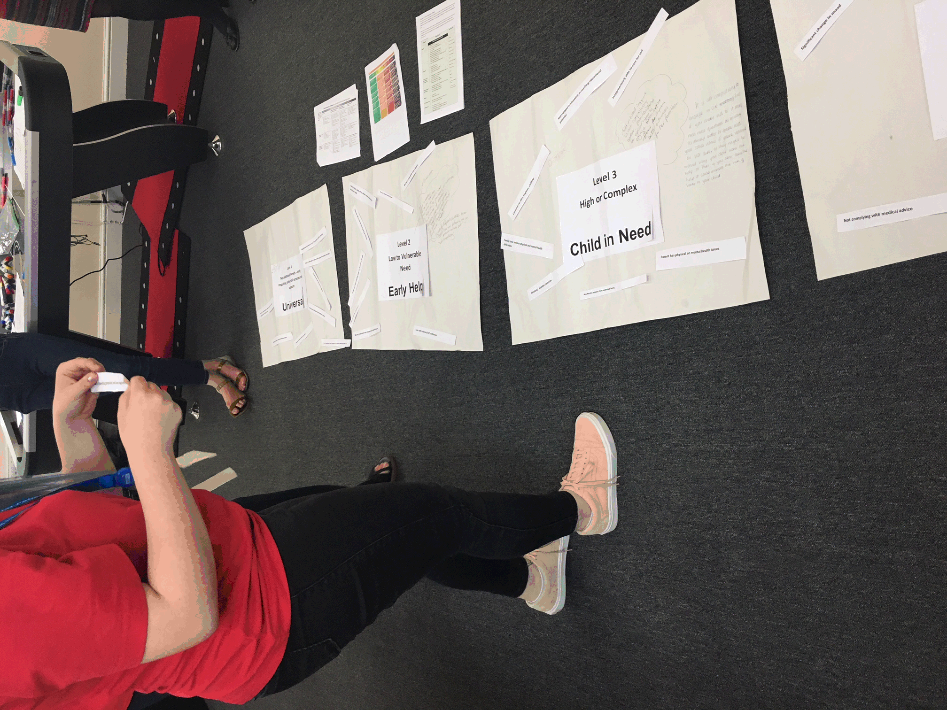**This document was published in November 2018**

