Growing in Christ

Parents Guide to the Early Years Foundation Stage Framework
Exciting times ahead for you and your child

What is the Early Years Foundation Stage?
Now that your children are settled within the foundation stage at Parish CE Primary School, we would like to give you some more information about the beliefs and ethos of the stage and also the aims that we have for your children to achieve by the end of the year.
This is a very important stage as it helps your child get ready for school as well as preparing them for their future learning and successes. From when your child is born up until the age of 5, their early years experience should be happy, active, exciting, fun and secure; and support their development, care and learning needs.

Parents Guide to the Early Years Foundation Stage Framework
Exciting times ahead for you and your child
What is the Early Years Foundation Stage?
Now that your children are settled within the foundation stage at
Parish CE Primary School, we would like to give you some more information about the beliefs and ethos of the stage and also the aims that we have for your children to achieve by the end of the year.
This is a very important stage as it helps your child get ready for school as well as preparing them for their future learning and successes. From when your child is born up until the age of 5, their early years experience should be happy, active, exciting, fun and secure; and support their development, care and learning needs.

- The legal welfare requirements that everyone registered to look after children must follow to keep your child safe and promote their welfare

- The 7 areas of learning and development which guide professionals’ engagement with your child’s play and activities as they learn new skills and knowledge

- Assessments that will tell you about your child’s progress through the EYFS

- Expected levels that your child should reach at age 5, usually the end of the reception year; these expectations are called the “Early Learning Goals (ELGs)”

- There is also guidance for the professionals supporting your child on planning the learning activities, and observing and assessing what and how your child is learning and developing.

What does it mean for me as a parent?
Ensuring my child’s safety

Much thought has been given to making sure that your child is as safe as possible.
Within the EYFS there is a set of welfare standards that everyone must follow. These include the numbers of staff required in a nursery, how many children a childminder can look after, and things like administering medicines and carrying out risk assessments.

How my child will be learning

The EYFS Framework explains how and what your child will be learning to support their healthy development.
Your child will be learning skills, acquiring new knowledge and demonstrating their understanding through 7 areas of learning and development.

Children should mostly develop the 3 prime areas first. These are:

- Communication and language;

- Physical development; and

- Personal, social and emotional development.

These prime areas are those most essential for your child’s healthy development and future learning.

As children grow, the prime areas will help them to develop skills in 4 specific areas.

These are:

- Literacy;

- Mathematics;

- Understanding the world; and

- Expressive arts and design.

These 7 areas are used to plan your child’s learning and activities. The professionals teaching and supporting your child will make sure that the activities are suited to your child’s unique needs. This is a little bit like a curriculum in primary and secondary schools, but it's suitable for very young children, and it's designed to be really flexible so that staff can follow your child's unique needs and interests.

Children in the EYFS learn by playing and exploring, being active, and through creative and critical thinking which takes place both indoors and outside.
As a mum or dad, how can I help with my child’s learning?

All the fun activities that you do with your child at home are important in supporting their learning and development, and have a really long lasting effect on your child’s learning as they progress through school.

Even when your child is very young and is not yet able to talk, talking to them helps them to learn and understand new words and ideas. If you make the time every day to do some of the following things with your child it will make a real difference to your child’s confidence as a young learner.

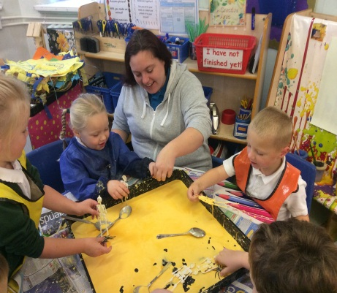
How can I find out how my child is getting on?
It is important that you and the professionals caring for your child work together. You need to feel comfortable about exchanging information and discussing things that will benefit your child. These conversations will either need to be with your childminder or, in a larger setting like a nursery, with your child’s “key person”.
This is the person who:

- Is your main point of contact within the setting

- Helps your child to become settled, happy and safe

- Is responsible for your child’s care, development and learning

- Takes a careful note of your child’s progress, sharing this with you and giving you ideas as to how to help your child at home.

When your child is 5?

At the end of the EYFS – in the summer term of the reception year in school – teachers complete an assessment which is known as the EYFS Profile. This assessment is carried out by the reception teacher and is based on what they, and other staff caring for your child, have observed over a period of time.

Another important part of the EYFS Profile is your knowledge about your child’s learning and development, so do let your child’s class teacher know about what your child does with you: such as how confident your child is in writing their name, reading and talking about a favourite book, speaking to people your child is not so familiar with or their understanding of numbers.

All of the information collected is used to judge how your child is doing in the 7 areas of learning and development. Finding out at this stage how your child is doing will mean that the teacher your child has in their next school year – year 1 – will know what your child really enjoys doing and does well, as well as helping them decide if your child needs a bit of extra support, what that support should be and if they are already getting it.

The school will give you a report of your child’s progress, including information from his or her EYFS Profile.
We hope that your child enjoys their time in the Foundation stage at Parish.

